28th January 2021

Dear Parents/Guardians,

You will be aware by now that students will be receiving Centre Determined Grades as their GCSE/AS/A2 grades this year. Thank you to those of you who attended the webinar on Assessment Arrangements for 2021. For those of you who may wish to see the recording, it is on our website.

As the grades are now determined by the centre, all the appeals will also be coming to the centre. Due to this, we have reviewed the information we are sharing with parents/guardians between now and the summer and this letter clarifies some points for your understanding.

- As was the case last year, it is important to note that these are ‘Centre Determined Grades’ not ‘Teacher Determined Grades’. The overall responsibility is not placed on the teacher; it is the responsibility of all leaders and ultimately the responsibility of Head Teacher as Head of Centre. Please do not therefore contact individual teachers with questions about grades that your child may achieve in the summer.
- The reports for the rest of the academic year will share with you the Current Working Grade (CWG). This gives you an indication as to what work your child is currently working on. This is not the same as the Professional Predicted Grade (PPG) which we usually share with students and parents. The CWG does not tell you what grade your child is likely to achieve in the summer, it tells you where they are at now.
- The purpose of the CWG is to communicate with students and parents where their child is currently working at. It will not be used to inform the Centre Determined Grade.
- Teachers will be able to tell you your child’s CWG and what they need to do to improve. They will not tell you what they think your child may be likely to achieve in the summer. Please do not ask them for this information.
- We do not know exactly yet which pieces of evidence will be used for the Centre Determined Grade. We are awaiting information from WJEC and Qualification Wales regarding the Assessment Framework.
- We do not know the dates for completion of course at the moment.
- We have not received any further information regarding BTEC subjects or the Welsh Baccalaureate Qualification.
- Key point for students at the moment is to work hard, engage with teachers, engage in all their learning and complete all work to the best of their ability.

Should you have any further questions, please contact Mr Fisher or Mrs Elgood in the first instance, or contact admin@penglais.org.uk

Yours sincerely,
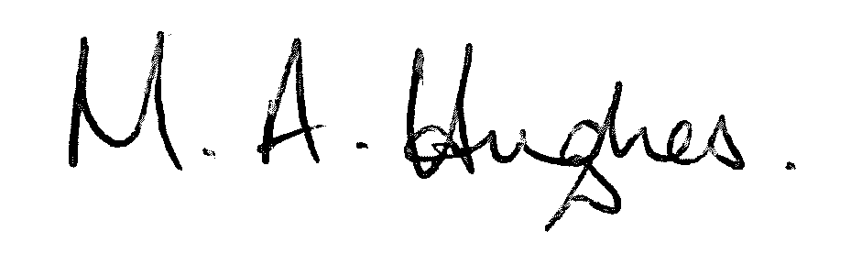
Ms M Hughes
Pennaeth/Headteacher

