20th January 2021

Dear Parents/Guardians and Students,

You may be aware that the Education Minister, Kirsty Williams, released today the revised assessments arrangements for GCSE/AS/A2 in 2021. Please see attached a letter from Kirsty Williams to all learners.

All learners in Wales this year will receive grades determined by their school based on work they have completed over their course. This replaces the three-pillared approach that was shared in December and therefore there will be no external assessments of any kind this year.

This approach places the trust in teachers’ knowledge of their learners’ work and allows them to prioritise teaching and learning in the time available this year to support learners’ progression.

I would like to invite you to a webinar on Thursday 21st January at 5pm to explain this in more detail and to enable you to ask any questions. Please use the link below to attend the webinar.

https://teams.microsoft.com/l/meetup-join/19%3ameeting_NTNkMDE2ZTQtZmNmMC00ZWNjLWIzN2ItMzVhOTQyYmRjYzU2%40thread.v2/0?context=%7b%22Tid%22%3a%224f3f0e52-b734-4164-9409-1b601d147993%22%2c%22Oid%22%3a%22c25aa25c-ddf5-4761-a64f-e5dece5b316b%22%2c%22IsBroadcastMeeting%22%3atrue%7d

Yours sincerely,

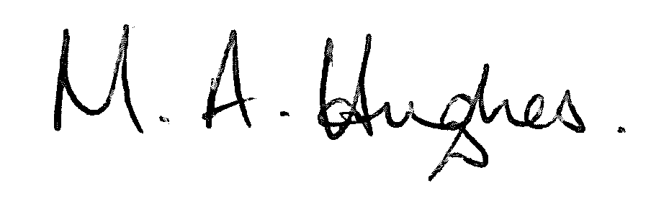

Ms M Hughes
Pennaeth/Headteacher

