MAH/hc

Dear Parents/Guardians

As you are aware many staff are working from home, therefore there is a limited number of staff working in the school. Should you need to contact us please call 01970 624811 alternatively you can email admin@penglais.org.uk. Do not leave messages on any other telephone number as these may not be actioned.

Many thanks for your continued support.

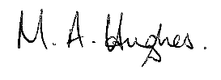

Ms M Hughes
Pennaeth/Headteacher

