15th January 2021

Dear Parents/Guardians,

I hope that you are all well and that you and your families are keeping safe. I also hope that the students have been working well over the last week and a half and enjoyed their learning. Thank you for all your efforts in supporting your child in accessing the school online provision.

As I stated in the letter on 8th January, we have started with a full timetable in place with every lesson having at least an element of live learning. I also stated that we would review this provision as we are aware of the need to balance teaching and learning with student and staff wellbeing. We know that this intensity of learning was successful for the four days in November, however sustaining it for potentially six weeks is a different consideration.

Following feedback from parents, students and staff, it has become clear that maintaining this is not going to be sustainable for all our students and staff. We are very conscious that students in Key stage 3 and 4 are at their devices for at least five hours a day and that this does not necessarily support the mental or physical wellbeing of all students.

The Welsh Government released guidance yesterday regarding expectations of remote learning for pupils in exam years (Expectations of remote learning for pupils in exam years - Hwb (gov.wales)). In this they state that learners should receive four hours of learning per day; that there should be daily contact with school; and that there should be a combination of live and non-live teaching as well as digital and non-digital learning.

We have also considered research that was completed following the first lockdown which recommends five key principles to consider:
- Teaching quality is more important than how lessons are delivered
- Ensuring access to technology is key, especially for disadvantaged pupils
- Peer interaction can provide motivation and improve learning outcomes
- Supporting pupils to work independently can improve learning outcomes
- Different approaches to remote learning suit different types of content and pupils

The following guidance will therefore be in place for students and staff from Monday 18th January onwards:

Years 7 - 9
- We will keep to the original timetable and all teachers will check-in with their classes at the start of every lesson to take register and check that students are well and understand the work
- At least half the contact time per subject will be live learning
- Teachers will consider how to best deliver the learning that is needed for students to understand the content and will plan accordingly. This may involve, for example, live explanation of topics; pre-recorded videos of themselves explaining work; use of videos on other websites; setting independent work for students.
- Teachers will give feedback on specific pieces of work to support students in identifying how they need to improve
- Teachers will tell students which lessons they will be available for contact and support
- The structure of the day will change with the break and lunch now being at the end of the lesson. Lessons will now be 80 minutes following the timetable below:
9 am Tutor time
9.15 – 10.35am Lesson 1
11.25 – 12.45 Lesson 2
1.35 – 2.55 Lesson 3

Years 10 - 13
- We will keep to the original timetable and all teachers will check-in with their classes at the start of every lesson to take register and check that students are well and understand the work
- Teachers will consider how to best deliver the learning that is needed for students to understand the content and will plan accordingly. This may involve, for example, live explanation of topics; pre-recorded videos of themselves explaining work; use of videos on other websites; setting independent work for students.
- Teachers will be available for contact and support in all lessons
- Lessons will now be 90 minutes
- Teachers will give feedback on specific pieces of work to support students in identifying how they need to improve

Additionally for Years 12 and 13, we will be expecting all students to have their cameras on for the lessons. This will support student engagement in lesson and help the teacher identify more quickly where there are issues. We also recognise that the workplace going forward will be much more dependent on virtual meetings and this is therefore an important work-skill to develop. Students should ensure that they are appropriately dressed; organised and prepared in the lesson; using a background for their camera.

We will keep the situation under review. Should you have any questions or need any support, please contact admin@penglais.org.uk.

Thank you for your co-operation as always.

Yours sincerely,

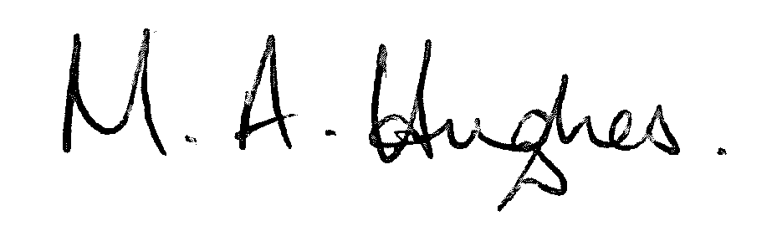
Ms M Hughes
Pennaeth / Headteacher

