HYWEL DDA -Apprenticeship Academy 2021

https://hduhb.nhs.wales/jobs/working-for-us/recruitment-campaigns/apprenticeship-academy-2021/

Announced today- 4/2/2021: Apprenticeships in:

1. Health Care.

2. Corporate Governance (Business Administration).

3. Patient Experience (Digital Media and Advertising)

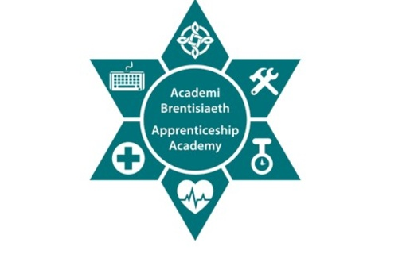
The Hywel Dda Apprentice Academy provides an excellent opportunity if you are looking to join the NHS. Whilst on a structured work based learning programme, you will be able to learn while you earn, gaining nationally recognised qualifications.
Apprenticeships can take between one and four years to complete and are available to anyone from the age of 16 years old. As well as being in the workplace, you will attend college or a training centre to work on your qualifications.
More information on the Apprenticeship Academy is available below as well as further information about recruitment opportunities within Hywel Dda University Health Board.
For more information, qualifications or apprenticeship queries, please contact the Apprenticeship Academy by email on apprenticeship.academy@wales.nhs.uk or telephone on 07971 480755.

Before you apply for the Apprenticeship Academy

Why apply for an apprenticeship in Hywel Dda?
Here’s just some of the reasons why:
- Apprenticeships are great first step into a career in the NHS
- Apprenticeships combine practical training with paid employment (‘learn while you earn’)
- An opportunity to work alongside experienced staff to support you and help gain the practical skills you need
- You gain nationally recognised qualifications, with no tuition fees
- 27 days paid holiday a year, plus additional public holidays
- Holiday entitlement increases with service
- A potential first step to professional training
- A great experience, working as part of a team, making a real difference
Invest in your future. Come and join the Hywel Dda family. There’s no better place to #TrainWorkLive

What does the Apprenticeship Programme involve?
You will:
- Attend an Induction which will prepare you for your placements within the health board
- Be supported by a workplace tutor
- Have a day a week with the college to develop your learning in the first year
- Receive support from an individual at the college
- Attend workshops where you will have the opportunity to discuss and share ideas
- Work towards qualifications, building the levels as you grow in confidence and experience

What are the entry requirements for the Apprenticeship Programme?
You must:
- be a kind, caring person who is passionate about helping others
- be aged 16+ in September 2021
- have lived in the UK/EEA for the last three years
- be able to demonstrate kindness and compassion and a passion for helping others
- be able to demonstrate a willingness to work hard
You must not:
- hold a full Level 3 qualification related to the Apprenticeship Programme you wish to apply for (if you are not sure if you do, please contact us)
- be in any formal government-funded education at the time of starting the Apprenticeship Programme

After you've applied for the Apprenticeship Academy

What happens after you've applied for the Apprenticeship Programme?
Once the closing date has passed, if you are successfully shortlisted, you will be invited to attend an assessment day in your county.
This will be a fun day and give you the chance to meet us as well as get to know more information about the programme. You will need to bring a packed lunch and drinks with you for this day.
You will be asked to bring the following documentation with you. Please read this carefully:
- Proof of the right to work in the UK
- Proof of identity
- You will also need to provide evidence for the DBS (Disclosure and Barring Service) check
Specific information regarding documentation we require will be on the vacancy advert on the NHS Jobs website.

- Health care apprentice information
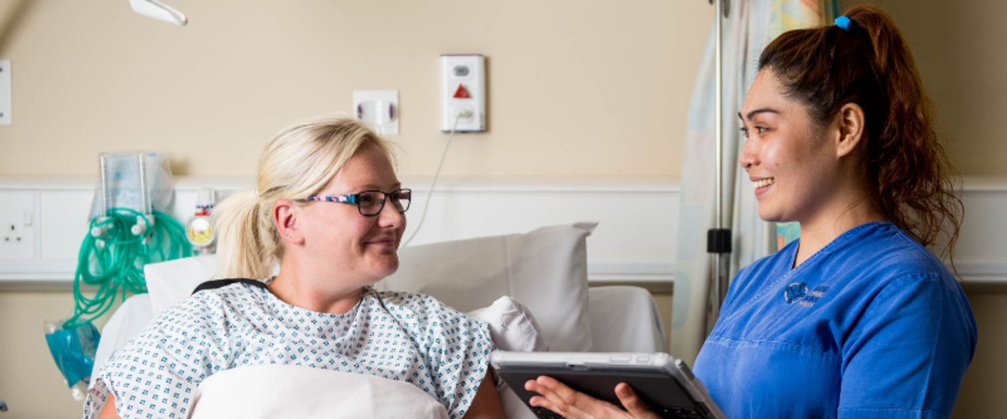
The Health Care Apprenticeship Programme is an exciting opportunity that will enable you to train to become a fully registered nurse through work-based learning.
You will complete a Foundation Apprenticeship in Health Care Support Services (level 2), progress to an Apprenticeship in Clinical Health Care Support (level 3), before embarking on part-time university education, starting at level 4.
When you have finished the programme, you will be a qualified registered nurse and will not have had to pay any university fees. You will be earning whilst you are learning the whole time.
Within the first two years, you will be working alongside registered nurses and other health care professionals. This will give you an insight into care whilst working with a mentor within patient areas, preparing to deliver care to patients. You will also have the chance to work with other areas, such as Therapies, Patient Administration and the Domestic teams.

- Corporate governance apprentice information
The Corporate Governance Apprenticeship Programme is an exciting opportunity that will enable you to train to become part of the corporate team through work-based learning.
You will complete a Foundation Apprenticeship in Business Administration (level 2), progress to an Apprenticeship in Business Administration (level 3), before embarking on part-time university education, starting at level 4.
When you have finished the programme, you will be an essential part of the team that advises the health board and will not have had to pay any university fees. You will be earning whilst you are learning the whole time.
Within the first two years, you will be working alongside the legal team and other professionals. This will give you an insight into the health board whilst working with a mentor within different areas, preparing to support and assist the board. You will also have the chance to work with other areas, such as risk, communication and the executive assistants.
Please note, when you have completed your training you will be expected to remain employed with the Health Board for a minimum of two years.

- Patient experience apprentice information 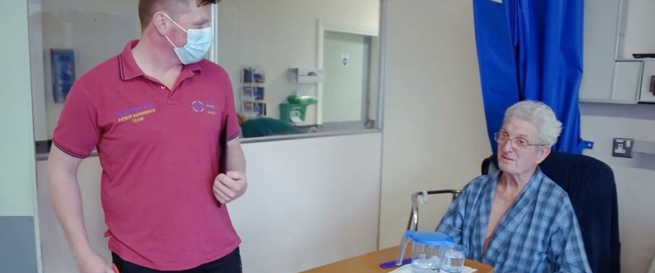
The Patient Experience Apprenticeship Programme is an exciting opportunity that will enable you to train to become part of the patient advice and liaison service (PALS) team through work based learning.
Route 1 - You will complete a Foundation Apprenticeship in Digital Application support (level 2), progress to an Apprenticeship in Social Media and Digital Advertising (level 3), before becoming a patient experience (digital) officer.
Route 2 - You will complete a Foundation Apprenticeship in Customer service (level 2), progress to an Apprenticeship in Customer service (level 3), before becoming a patient experience (customer service) officer.
When you have finished the programme, you will be an essential part of the team that provides support to patients and services to the entire health board and will not have had to pay any fees. You will be earning whilst you are learning the whole time.
Within the first two years, you will be working alongside the PALS team and other professionals. This will give you an insight into the Health Board whilst working with a mentor within different areas, preparing to support and assist the team. You will also have the chance to work with other areas, such as patient experience, and family liaison.
Please note, when you have completed your training you will be expected to remain employed with the health board for a minimum of two years.

If you would like to discuss the Hywel Dda Apprenticeships further with Wyn Davies, Careers Adviser at Penglais Comprehensive School please contact: wyn.davies@gyrfacymru.llyw.cymru
or telephone: 07443 293315

