26th March 2021

Dear Parents/Guardians of Year 7, 8 and 9,

As we end this term, I would like to take the opportunity to thank you as parents and guardians for the support you have given your child and the school in helping your child access the online learning over the last term. It has been a challenging time for all and we are so looking forward to seeing all students back on site in April.

Students in all year groups will be returning on Monday 12th April. Many of the arrangements that were in place previously remain in place now. It is worth going through these again with your child to remind them of the expectations when they return. The main difference for students is that they will need to wear the face coverings in the classrooms and they will no longer be expected to wear them outside at break and lunch time.

To remind everyone, the following control measures that were in place prior to the lockdown will continue. This includes:

- ensuring good hygiene, with plenty of hand washing opportunities during the day and supplies of sanitiser in corridors and classroom. Students and staff are expected to sanitise their hands on entry to every classroom.
- spray and wipes in every classroom and students and staff will be expected to clean the chairs and tables at the end of every lesson
- all windows and doors will be open to ensure good air circulation
- taking every child’s temperature at the start of the day, and any child with a temperature of 37.8 degrees or higher will be sent home
- cleaning will take place during the day as well as after school hours
- managing the movement of students around the school site and between classrooms
- students and staff are now expected to wear face coverings in classrooms, corridors and during movement around site but not in outdoor places
- students will sit facing the front of the class
- the Test and Trace method will be implemented in the school in the event of a case of Covid-19
It is crucial that all members of the community adhere to these expectations diligently at all times.

Arrangements for students returning to school site
Transport
If your child usually travels to school by bus or taxi, those arrangements will continue in terms of collection time and location. Ceredigion Council expects students to wear a face covering on school transport. All students have been given two re-useable face coverings by the school.
Food
The canteen will be open to all students from 12th April. Please remember to bring in plenty of water for the day as the fountains will remain out of use.

Provision and Equipment
There is a need to ensure that personal equipment e.g. pencils, rulers etc. are not shared during the day. Please ensure that your child has the appropriate equipment ready for their return to school.

School Uniform
Please ensure that your child is in full school uniform. Normal school uniform will be expected by all students. This includes the school PE kit which they will need to wear on the day of their PE lessons. See link to the school uniform expectations http://penglais.org.uk/index.php/information/school-uniform.html. If there are any problems in terms of school uniform, please contact us on admin@penglais.org.uk.

Start and finish time
Students are asked not to arrive on site before 8.25am if dropped off by parents or walking to school. If walking up Cefn Llan, students should use the pedestrian gate by the 6th form centre. Students must go straight to their form tutor classroom when they arrive in school and should not congregate with other students. Students should enter through the designated door closest to their tutor room and should only enter the building through this door.

The school site
Students will need to follow the one-way system around the school site to keep the school community safe and once they enter the school building, they will need to go straight to their tutor room for registration.

Despite the number of safeguarding measures that will be implemented to ensure the wellbeing of all, we are committed to ensuring that your child’s learning experience is meaningful, enjoyable and within a safe environment. We are planning carefully to ensure that the experience of returning to school is a positive one for your child. Children will be expected to return to school and usual attendance procedures will be applied. If you have any concerns or would like to contact us with further questions please do so by emailing admin@penglais.org.uk.

A sincere thank you to you as parents/guardians for your continued support, and we are really looking forward to welcoming the students back to school site from 12th April. In the meantime, please enjoy a good break over the Easter holiday.

Yours sincerely,

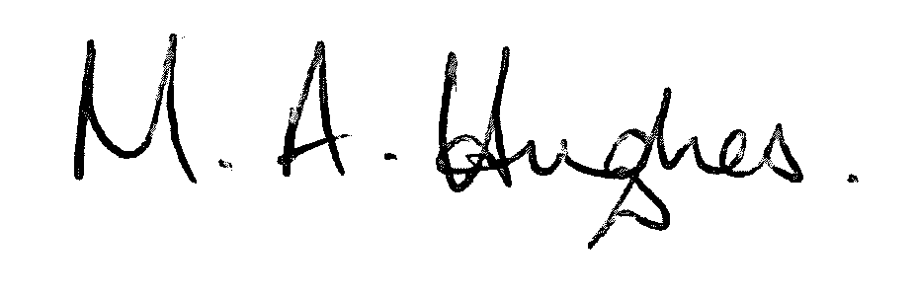

Ms M Hughes
Pennaeth/Headteacher

