3rd March 2021

Dear Parents/Guardians,

I write to inform you of our arrangements for welcoming more students back to school from the week commencing 15th March onwards. Final confirmation of these arrangements will take place after the First Minister has made a statement on 12th March, due to the need to act in accordance with the public health situation at the time. However, we want to communicate our plans with you so that we can all prepare for a return to face-to-face learning.

Return to school
During the week commencing 15th March we will be welcoming exam groups back to the site as follows:
Year 11 | Monday 15th March
Year 12 | Wednesday 17th March
Year 13 | Monday 15th March

In order to limit the number of students on site, we continue to ask 6th form students to only be on site when they have lessons, where this is possible.

During the week commencing 22nd March, we will welcome year 10 pupils back to the site for face-to-face learning. We will contact the parents of students in years 7, 8 and 9 individually as regards to any arrangements for a possible ‘check in’ before Easter.

To confirm, an INSET day will not be held on Friday 26th March, as set out in the school calendar. The school will be closed for the Easter Holidays from Monday 29th March, and re-open on Monday 12th April.

Face covering
All students will be required to wear a face covering in class, in corridors and in communal areas when not eating and drinking, unless there is a medical reason that exempts them from doing so. Students travelling to school by bus or taxi will also have to wear a face covering on school transport. We will no longer require students to wear face coverings outside at break or lunchtime.

Safety
All control measures previously implemented by the school will remain in place as regards to contact groups, taking temperatures, one-way corridors, hygiene and additional cleaning.

Transport
School transport will run as normal from 15th March for eligible pupils. If possible, we would be grateful if you could transport your child to school in order for us to reduce the numbers on the buses.

Food
The canteen will open from 15th March in the main canteen for KS4 students and will open to all students, including 6th form, from 12th April.

School Uniform
Students are expected to return to school in their uniform. Please contact the school for a further discussion if there are any problems regarding uniform.

Lateral Flow Tests
Students from years 10, 11, 12 and 13 will be able to receive one-way flow tests for use in the home. There will be more information to follow in terms of instructions for these tests. Students will collect their tests from school and receive enough for 3 weeks. Students are expected to implement the tests on Sunday and Wednesday evenings and contact the school immediately if the test is positive.
The school should be contacted on these evenings by emailing testing@penglais.org.uk

Symptoms
Anyone with Covid-19 symptoms should immediately stay at home and book a test. The entire household needs to self-isolate until the result of the test is known. Symptoms include a high temperature, a new continuous cough and a loss or change to sense of smell or taste. There can be other symptoms early on, such as headaches, tiredness and general aches and pains usually associated with flu.

Regulations
Although we hope that students can return to school from 15th March onwards, the current regulations continue to ask everyone to keep within their household and not mix with others. We kindly ask you to remind your child of these requirements.

We very much look forward to being able to welcome your child back to the school site. Thank you very much as parents and guardians for all your efforts to assist with your children's education throughout this period.

Should you have any further questions, please contact admin@penglais.org.uk.

Yours sincerely,

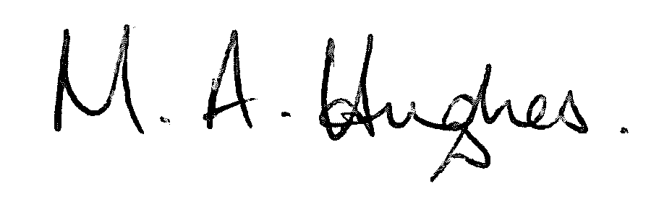

Ms M Hughes
Pennaeth/Headteacher

