HGG/hc

26th March 2021

Dear Parents/Guardians,

We have had a very busy couple of weeks with our older students settling back into site and are delighted with the attitude they are showing towards their work and assessments.

We would just like to take this opportunity to remind you all of our uniform policy and requirements. In Year 10 and 11 all students need to wear a Penglais school jumper, white shirt, school tie and have black school trousers and shoes.

We understand that some of our Year 11 students will be leaving us in the summer term so we understand if parents cannot spend money on new uniform at this stage. Therefore, if this is the case, we ask the bottom half of the uniform to be plain black with no logos and there to be no trainers. We will purchase a stock of school jumpers for Year 11 to borrow. We cannot have any hoodies or non-school jumpers worn on school site but students can still wear their coats as previously.

In Year 10 we expect full school uniform at all times and again, we do not expect to see any non-school jumpers or hoodies.

We understand this time has been exceptionally difficult for lots of us so if you need any help purchasing any element of school uniform please do not hesitate to get in touch as we may be able to help.

Please email your Head of Year if there are issues with any of the above.
Year 10 s.johnson@penglais.org.uk
Year 11 af@penglais.org.uk

We look forward to a highly productive term from 12th April and wish you all a peaceful Easter break.

Yours faithfully,
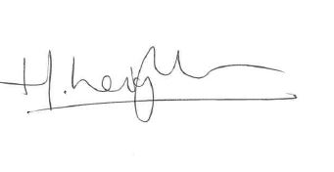

Ms H Leighton
Deputy Headteacher

