MAH/hc

27th April 2021

Dear Parents/Guardians,

We have now received guidance from the Welsh Government regarding the period following the assessments. There is no requirement for Year 11 and 13 students to attend school after 28th May and there will be flexibility for schools to focus on ensuring successful transition to their next stage of education. This letter outlines the activities that will be available for students during the half term.

Key dates across Years 11, 12 and 13:
Date | Activity
Thursday 27th May | Last day of the half term
Friday 28th May | INSED
Wednesday 9th June | INSED
Wednesday 16th June | Sharing of provisional results

Year 13:
Students will have a session on May 27th in the afternoon to finish their time at Penglais. The 6th form team will share further information about this.

Year 12:
Students will have work provided online for the week beginning 7th June and will return to lessons in school from Monday 14th June.

Year 11:

Date | Activity
16th June | Sharing of provisional results
22nd – 25th June | Week of virtual lessons for all 6th form subjects
28th – 30th June | Enrolment days for the 6th form
1st – 2nd July | Induction days for the 6th form (all students to attend one of the two days)

As the provisional results are shared before the end of term, we are bringing forward activities such as the enrolment and induction days that would usually take place during the summer holidays and at the start of next term. For students returning to the 6th form, we will be giving opportunities for students to have virtual taster sessions in their chosen subjects. Having had a rather disjointed Years 10 and 11, it will be very important that students are able to attend these sessions as it will give them a useful feel about the subject in the 6th form and teachers will give students work and reading lists to prepare them for September. Further information and timetable will be shared with students later in the half term.

We are working with Coleg Ceredigion to prepare induction for students who are intending to attend Coleg Ceredigion from September.

I hope that this gives you a clear indication of key dates for the month of June/July which will therefore allow you to plan your time with your son/daughter in Years 11 and 13. We are still waiting for further guidance from WJEC regarding the appeals process and will share information with you as soon as this is possible.

Yours sincerely,

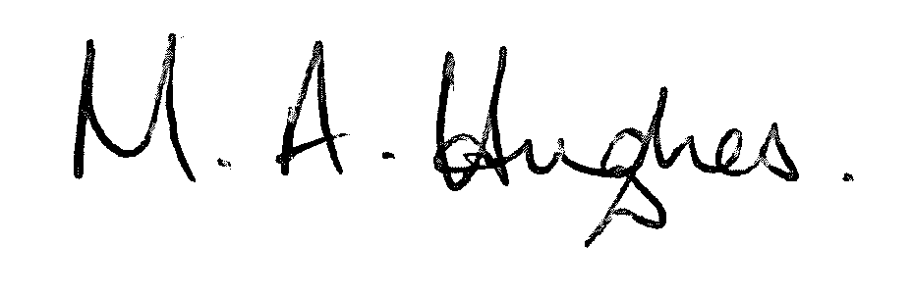

Ms M Hughes
Pennaeth/Headteacher

