MAH/hc

20th April 2021

Dear Parents/Guardians,

I hope that everything is well and that your child is enjoying being back on school site. We are certainly enjoying having them back and being able to support them more directly in school.

We have been very impressed overall with the positive attitude and approach that the students in Years 11, 12 and 13 have shown since their return to school in March. They seem to be responding well to the assessment tasks and appear to be taking the situation in their stride. However, we are aware that students can often mask the true situation. We are also aware that this can be a challenging situation for parents to deal with, especially as this is slightly different to the usual exam season.

We are here to support your child and yourselves. Please contact us in the school if you have any queries, concerns, or if you feel your child needs a bit of support. You can either contact your Head of Year (AF@penglais.org.uk; jje@penglais.org.uk); member of the 6th form support team (snt@penglais.org.uk); member of Student Services (cej@penglais.org.uk) or email admin@penglais.org.uk. The Assessment Policy for 2021 will be on the school website by the end of this week.

We are still waiting confirmation of end date for Years 11 and 13. We are finalising the dates for sharing the provisional grades with the students in Years 11, 12 and 13 and will share these with you as soon as possible. Year 11 enrolment interviews and induction dates into the 6th form will be confirmed once the dates above are known.

Yours sincerely,

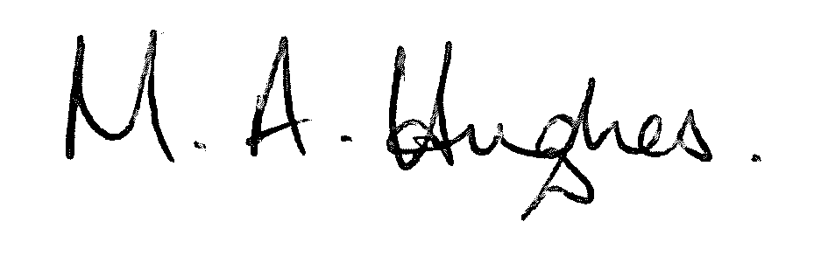

Ms M Hughes
Pennaeth/Headteacher

