MAH/hc

19th April 2021

Dear Parents/Guardians
Re: Parents’ Survey Results

You will be aware that every year we carry out a survey with all students, staff and parents. The purpose of this letter is to give you feedback on the results of the parents’ survey and how we intend to further develop areas in the school.

The number of parents/guardians who responded to the survey this year was 156 which is lower than in the previous years. I understand that there have been a number of additional surveys that we have asked you to complete over the last year in relation to online learning and therefore accept that the number completing the annual survey may be lower this year. On the whole, the parents’ responses this year show a marked improvement in level of satisfaction compared with previous years.

The questions with the highest levels of satisfaction are as follows:

Question | % who agree / strongly agree | Percentage point improvement on last year
The school is well led and managed | 96% | +13
My son/daughter feels safe at the school | 95% | +5
My son/daughter is well looked after at the school | 93% | +8
My son/daughter is happy at the school | 90% | +0.5
My son/daughter is taught well at the school | 90% | +8.5
The school deals effectively with bullying | 89% | +17
I would recommend this school to another parent | 88% | +10
The school has clear, high and positive expectations for my son/daughter | 87% | +3
The school makes sure its students are well behaved | 86% | +17

We are very pleased, but not complacent, about these, particularly that the highest are that you feel your child is happy and safe, and are taught well at the school. This is the bedrock for any academic success. We are also pleased that two areas that were amongst the areas to develop last year, that the school deals effectively with bullying and that the school makes sure its students are well behaved, are this year in the areas with highest level of satisfaction.

The five questions with the lowest levels of satisfaction are as follows:

Question | % who agree / strongly agree | Percentage point change from last year
My son/daughter’s books are marked regularly with useful feedback | 63% | -7
The school responds well to any concerns I raise | 71% | -6
My son/daughter receives appropriate homework for their age | 76% | -2.5
I receive valuable information about my son/daughter’s progress | 78% | +11
The school provides my son/daughter with the help and support they need | 78% | +4.5

Whilst two of these show an improvement on last year, there are three questions here where level of satisfaction has decreased since last year. We will look at these in the school and ensure that there are areas in our School Improvement Plan to address these. During this term, we will be reaching out to you to understand how you would like to see some of these areas improved.

We have also analysed the comments that were made and are very grateful for the time you have taken to complete the survey. It is an important tool for us to be able to continue on our journey towards becoming an excellent school at Ysgol Penglais.

Yours sincerely,

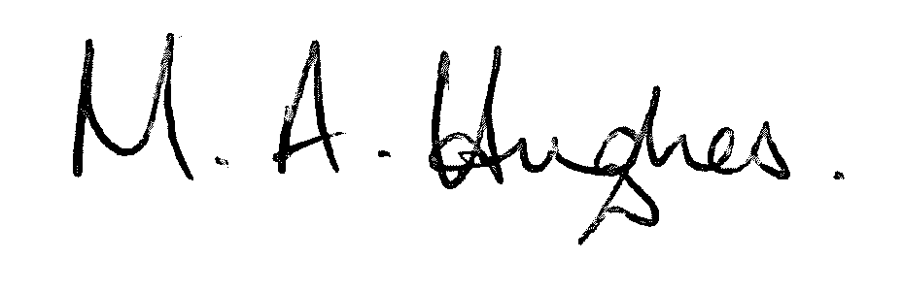

Mair Hughes
Pennaeth/Headteacher

