21st May 2021

Dear Parents/Guardians and students,

We have recently received the guidance about this year’s appeal’s process from Qualification Wales and WJEC. This letter sets out the stages to the process and we will be now working on the details for Stage 1. We will hold a webinar on Wednesday 26th May to go through the process for stage 1 in more detail, including how we decide the Centre Determined Grade and the information we will be sharing with the students when we share the provisional results.

There are three stages to this year’s approach:
Stage 1 – Centre review
A learner can request a centre review of the provisional Centre Determined Grade on the grounds that there has been an error in the determination of their grade. Learners must identify the reasons why they believe there has been an error in the determination of their grade. Grades can go up, down or remain the same as the result.

Stage 2 – Appeal to WJEC (following completion of Stage 1)
An appeal to WJEC on the grounds that the judgement that the centre has made is unreasonable and/or a procedural error has been made. Learners must identify the reasons why they believe the centre has made an unreasonable judgement and/or a procedural error. Grades can go up, down or remain the same as the result.

Stage 3 – EPRS – Qualifications Wales (following completion of Stage 2)
A request to Qualifications Wales for an Exam Procedures Review Service (EPRS) to review whether WJEC has followed the required procedures.

Please click on the link below to attend the webinar on Wednesday 26th May at 6pm. It is important that as may parents/guardians and students attend as possible so that you have a full understanding of the process.

https://teams.microsoft.com/l/meetup-join/19%3ameeting_ZWIwODdhMTEtMTc5Zi00NTliLWI4MzItMjA1YTg0OTkzY2E1%40thread.v2/0?context=%7b%22Tid%22%3a%224f3f0e52-b734-4164-9409-1b601d147993%22%2c%22Oid%22%3a%22c25aa25c-ddf5-4761-a64f-e5dece5b316b%22%2c%22IsBroadcastMeeting%22%3atrue%7d&btype=a&role=a

You will also find attached in the email a document from Qualifications Wales giving more information for learners about the whole process. Qualifications Wales are also interested in hearing from learners about their experience of the assessment process. They have created a link to a ‘Have your Say’ survey – please complete if you can: Qualifications Wales Have Your Say (smartsurvey.co.uk)

Thank you for your co-operation as always and we look forward to seeing you in the webinar.

Yours sincerely,

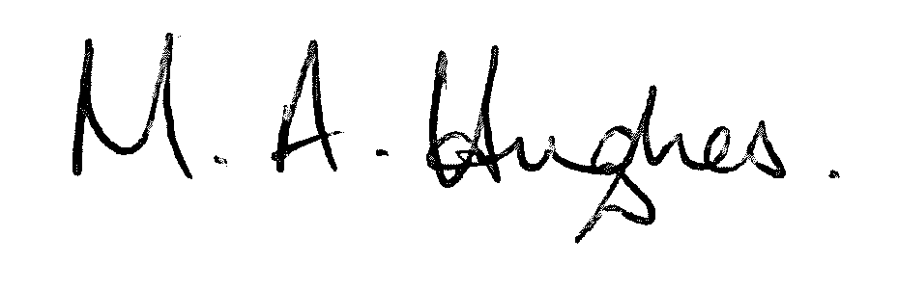

Ms M Hughes
Pennaeth / Headteacher

