16th June 2021

Dear Parent/Guardians and Students,

During the day today, students will have received their provisional results and the decision-making record for each grade. I hope that students are satisfied with their results and understand the decisions made for each grade.

This letter outlines the process should the student have any queries about any grades or if they think an error has been made in determining a grade.

If you have any questions or queries about any grade, there is an opportunity for you to meet or have a phone call with a senior member of staff to discuss the grade. To do this, please email exams@penglais.org.uk with the name of the student, qualification type (GCSE/AS/A2), subject, and indicate whether you would prefer to come to school for an appointment between 3.45 – 5.30 on Thursday or whether you would like a phone call on Friday.

Following this meeting, should the student believe an error has been made, then they can start the Stage 1 of the Appeals process, which is the centre review process. As grades have been created in school this summer, any appeals about the grades must come to the school, in the first instance. For a Stage 1 appeal, the attached form must be completed, in which the student explains the error in the grade. The completed form must then be emailed to exams@penglais.org.uk. The deadline for receiving applications for a centre review is Friday 25th June. Applications will not be considered if they are received after this date.

Students should receive the outcome of the appeal by the end of term. Should they not be happy with the outcome of the result, they will be able to then Appeal to WJEC as Stage 2 of the appeals process. This can only be done through the school and after the results are shared in August. However, we do ask for students to let us know before the end of term if they are likely to proceed to Stage 2. Students cannot proceed to Stage 2 unless they have completed Stage 1 of the process.

Please see the attached appeals policy for further information.

Yours faithfully,
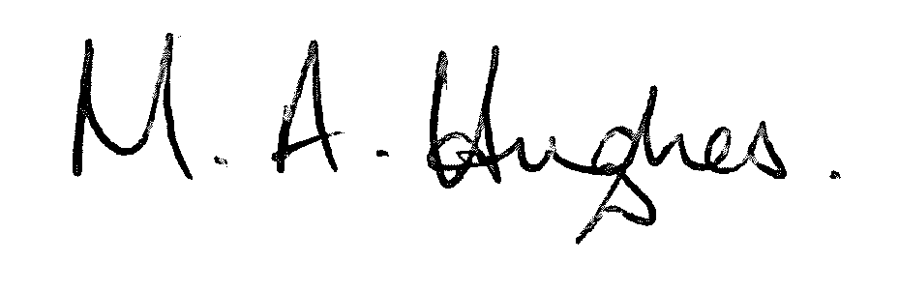
Ms M Hughes
Pennaeth/Headteacher

