MAH/hc

14th June 2021

Dear Parents/Guardians and Students,

As you are aware, the provisional grades and the decision-making records are being shared with all students in Years 11, 12 and 13 on Wednesday 16th June, at set times during the day. Year 12 will receive their results between 9am and 10am; Year 13 between 10am and 12pm, and Year 11 should come into school between 1.35pm and 1.45pm.

If you would like to discuss the grades, we can arrange an appointment or a phone call with a member of the Senior Leadership team. The appointments can be held in person between 3.45pm and 5.30pm on Thursday 17th June, or phone calls can be arranged on Friday 18th June. Please email exams@penglais.org.uk with the following information to request a meeting:

Name of student
Year Group
Level (GCSE, AS, A)
Subject
Grade given
Phone call or appointment at school preferred

We appreciate that this may be a stressful time for you and your child and want to reassure you that all enquiries will be dealt with promptly.

Yours sincerely,

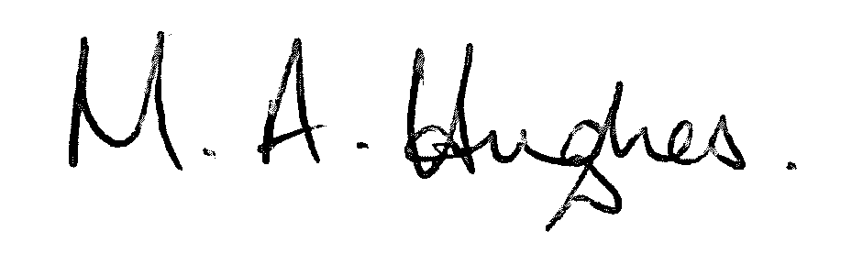

Ms M Hughes
Pennaeth/Headteacher

