healthy school b&w.tifeco school clear bkgrd side by side.tifactive marc cymru clear.tifai to photoshop test top lh.tifgriffin clear bkg.tif

10th June 2021

Dear Year 11,

***Sixth Form Enrolment Days***

Thank you for expressing your interest in Penglais Sixth Form. I am pleased to inform you that we are holding a place for you for September 2021, subject to you achieving our entry requirements.

Advanced level qualifications are a big step up from GCSE and we therefore require 5 GCSE passes A*-C including Maths and English for entry into our Sixth Form. Please be advised that for certain subjects, higher grades are needed to ensure access to the courses. Specific information can be found in our Sixth Form booklet but please contact us for further details if you have any queries regarding this. We are committed to ensuring that you achieve the best possible outcomes on leaving Penglais, both in terms of your academic results and personal development. We, in turn, expect commitment and determination to succeed from our students. A level study is challenging but if we work together we can ensure success.

Enrolment sessions for students hoping to come to study at Penglais Sixth Form will take place on **Monday 28th** **June, Tuesday 29th June and Wednesday 30th June 2021**. Each session will last approximately 15 minutes and the sessions are available between 9.15am and 3.00pm on each day. The purpose of the session is for you and your parent/ guardian to meet with a member of staff to review your GCSEs to ensure that each individual student is on an appropriate programme of study.

All students hoping to join the Sixth Form are expected to attend an enrolment session with their parent/ guardian. We cannot guarantee that you will be able to study with us until enrolment is complete.

Please ***email Miss Sian Thomas on*** [***snt@penglais.org.uk***](mailto:snt@penglais.org.uk)***to book an enrolment appointment.***

We recommend that this is done as soon as possible to secure a convenient time.

You are required to bring the following completed documents when enrolling. These documents will be emailed to you along with confirmation of your appointment:

* Penglais Learning Agreement
* Wi-Fi Consent Form
* Completed Admission Form (if you did not study at Penglais in year 11 and have not already submitted this form)
* Biometric System Agreement
* Your preferred finalised options for AS - *Only one option from each box is permitted*
* £15.00 Sixth Form Levy - Cheques to be made payable to ‘Penglais School’
* Copy of GCSE results – external students only

The new term will begin for all students on Friday 3rd September 2021 at 8.45am in the Sixth Form Centre.

In the meantime, please do not hesitate to contact us should you require any further information.

Yours sincerely,

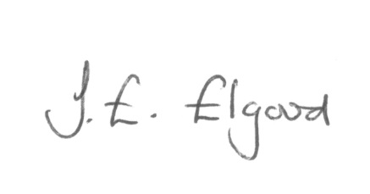

Mrs. J. E. Elgood

Head of Sixth Form

The documents above are available to download by following the link below:

<http://penglais.org.uk/index.php/post-16/links-and-documents.html>

The new term will begin at 8.45am on Tuesday 4th September 2018 in the Sixth Form Centre.

In the meantime, please do not hesitate to contact us should you require any further information.

Yours sincerely,

*A.Fisher*

*Pennaeth/Headteacher:- Ms Mair Hughes*

Waunfawr

Aberystwyth

Ceredigion

SY23 3AW

*Ffôn/* Tel: 01970 624811

*Ffacs/*Fax: 01970 625830

*E-bost/*E-mail: admin@penglais.org.uk

*Gwefan/*Website: www.penglais.org.uk

Yours sincerely

Mr R Edwards

Art Department