MAH/hc

25th June 2021

Dear Parents/Guardians and Students in Year 11

On Wednesday a letter was sent regarding the induction days at Ysgol Penglais School on Thursday 1st July and Friday 2nd July. In the letter is asks all students to take a lateral flow test the day before their induction day.

If your child does not have any lateral flow tests, please may I ask you to email admin@penglais.org.uk to request an LFT. Once we receive your request by email for a LFT, you will be emailed to invite your child to come to school to collect the test.

If your child has not previously requested the LFT, but would like to request a test please may I ask your child to complete the consent form so that they are able to receive a LFT. If your child completes a consent form, they may bring the form in when they collect the lateral flow test.

You must have received a reply by email before coming up to school to collect the LFT.

Yours faithfully,

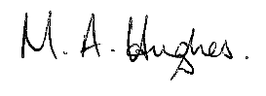
Ms M Hughes
Headteacher

