15th July 2021

Dear Parents/Guardians,

As we end the most unusual of academic years, I must start by thanking you as parents and guardians for your unfailing support this year for your child and for the school. You have responded to all the demands we have made as a school with patience and co-operation, despite the impact it may have had on you as a family. Your support for your child during the lockdown was valued and those of you who have had students in Years 11, 12 or 13 have also had to endure a very stressful few months up to the end of May – well done and thank you.

Throughout the year, students have also shown tremendous resilience and patience in dealing with everything that has been thrown at them. The guidance from the government has changed frequently and students have met the expectations without questioning. We understand that the past sixteen months may have been very difficult for some students and families and hope that we have been able to support students as needed. Through everything, students have responded patiently, resiliently and in good humour and, as staff, we are very grateful to them for this.

I must also publicly thank all staff for their hard work, resilience, flexibility and commitment in making the year as easy as possible for students. We have all upskilled our online teaching in ways that we never thought would be needed. Teachers and teaching assistants have been brilliant in trying to find different ways to engage students online and ensure that their learning continues as best as possible from home. All support staff have also worked hard in supporting families and doing all the work that often goes unseen to ensure that the school runs as smoothly as possibly, whether on site or virtually. The work done to ensure that the CDG process was completed as successfully as possible for students was immense and staff worked extremely hard to ensure that students had the opportunities to achieve their best.

Overall, I think this last year has been a great example of everyone co-operating to ensure that our students get the best experience and support as possible during a difficult time. Thank you all.

Return to school date
All students will be returning to school on Friday 3rd September.

Covid situation
I would like to be able to say with confidence that next year will be back to normal. Unfortunately, this is not the case. We have currently received some guidance from the Welsh Government and will be working on a phased approach in September, waiting for further guidance which will be released in September. Our aim is to provide a safe and supportive environment for your child and our decision-making process will be in conjunction with Ceredigion Council and the Local Health Board. At the moment, the following stands:

- Face coverings will be worn on school transport. We would continue to be grateful if you could transport your child to school as this will decrease the number of students on school transport. All students eligible for school transport will still be offered a place and routes will run as arranged.
- Staff and students will not have to wear face covering whilst in lessons. We will respect any staff or student who may choose to continue to wear a face covering.
- Staff and students will be required to wear a face covering in busy communal areas, for example, at all times in corridors; when queuing for lunch in the canteen; at busy times in the 6th form centre.
- For the first weeks in September, your child will remain in a contact group for their year group whilst we consider expanding the size of some contact groups in some settings.
- Our usual practices of checking temperatures, hand hygiene, good ventilation and one-way systems will continue.
- Students will need to take their Lateral Flow Test (LFT) on Sunday 18th July and then take another one on Wednesday 1st September, prior to their return to school on September 3rd. Should there be a positive test, please ensure that you email testing@penglais.org.uk.
- Any family who wishes to order LFTs can do so through the following link https://gov.wales/get-rapid-lateral-flow-covid-19-tests-if-you-do-not-have-symptoms

If there are any changes over the Summer holidays, we will update you by 1st September.

Uniform
It is important that your child has the appropriate school and PE uniform for returning to school on 3rd September as outlined on the school website School Uniform | Ysgol Penglais School or in the attached document. A reminder that non-school jumpers or cardigans, including hoodies, are not allowed on school site. The PE uniform has not been well worn by students this year so please ensure that your child has the correct PE uniform.

News and events
As usual, our half termly newsletter has lots of information about the on-goings in the school. Please have a good read.

Staff leaving
Every year, we say goodbye to some staff at the end of the year. This year, we have already said farewell to Mr Bentley (Maths) who has been a character of the school for a number of years. He will be missed as a colleague and an excellent maths teacher. Mrs Hague (Food Technology) has been responsible for the lovely food that your child has cooked in school for the last 19 years! She has inspired many a student to cook and will be missed in the school. Mx Gallon will be leaving her role in the 6th form and I know will be missed by the 6th form team and students. Mrs Williams (Maths) will not be returning from her maternity leave and we wish her well with her family up in North Wales.

New staff arriving
I am pleased that we have a number of high-quality staff starting with us in September. Ms Stroud will be joining the science team; Mr Bucicov and Mr Retter will be joining the Design and Technology department; Mrs Thomas will be joining the Maths team and Miss Nardiello will be continuing as a permanent member of the Maths Faculty; Mrs Jenkins will be our new Health and Social Care teacher; Mrs Blair will be teaching more Music and Drama and Mrs Evans will be in a new role as an ALN Teacher-coach. Mr Kingsbury has been appointed as Head of Social Sciences. Miss K Harper will be joining the ALN team as an ALN Support Manager whilst in the 6th form, Miss Asukile will be the 6th form support and Miss Yates will be joining as a learning coach. Mr Durand will be joining the English team to support the Literacy intervention and Mr Mercer will be helping the Maths team with Numeracy intervention. Miss Tyniec will be joining us to support the exams and data office and Mrs C Smith and Ms Barlow will join as cover supervisors. We look forward to welcoming all staff in September.

In the meantime, I wish you all as families a safe, warm and enjoyable summer. We look forward to seeing everyone return refreshed, rested and healthy in September.

Yours sincerely,

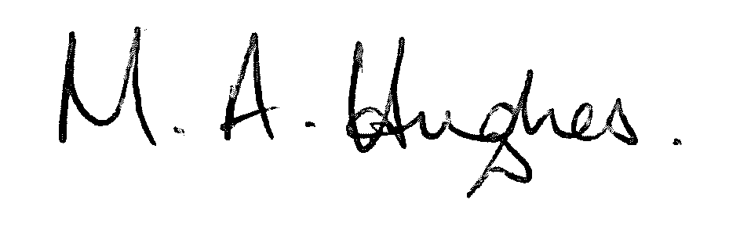

Ms M Hughes
Pennaeth/Headteacher

