10th September 2021

Dear Parents/Guardians,

You will be aware that guidance around self-isolation has now changed, with anyone identified as a close-contact of a positive case not needing to self-isolate if they are under 18 or have received double vaccination. It is also currently the case that anyone living in a Covid positive household again do not have to self-isolate if they are under 18 or have received double vaccination.

It is so important that we are able to keep schools open and hope that this will be possible throughout the year. Therefore, as a school, we are working incredibly hard to try to make the school as safe as possible for the whole community, whilst also trying to ensure that all students receive the education and emotional support that they need.

We would therefore like to request the following support from yourselves:

- If you choose to send your child to school even though they are living in a Covid positive household, we request that you inform the school and that the child takes a daily Lateral Flow Test. We can supply these from the school so please contact reception should you require more tests. This is as well as the PCR test that your child is required to take on days 2 and 8.
We would also like your child to consider wearing a face covering within the school. There are a number of students who do choose to wear a face covering in the classroom so there is no risk that your child would stand out by wearing a face covering.

- If your child has received a ‘Warn and Inform’ letter, again, we would ask your child to consider wearing a face covering within the school. Should your child wish to take a daily Lateral Flow Test as well as the PCR test on days 2 and 8, then they are welcome to do so.
These would be voluntary actions and we are not insisting that your child takes these actions. However, they are worth considering to support our school community in keeping as safe as possible.

Thank you in advance for your co-operation. Should you have any questions, please contact admin@penglais.org.uk.

Yours sincerely,
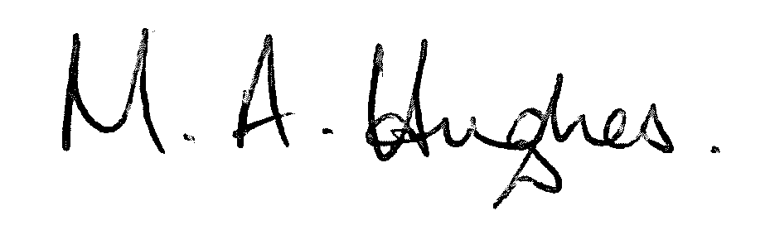
Ms M Hughes
Pennaeth/Headteacher

