2nd September 2021

Dear Parents/Guardians,

I hope everyone is well and that you have had a good break over the summer. We are very much looking forward to welcoming the students back on Friday 3rd September and are sending this letter out in advance to ensure awareness of key issues before students return.

When students return on Friday 3rd September, many of the regulations that we had in place at the end of last term will continue. The list below summarises expectations on return and until Monday 13th September in the first instance, unless specified differently:

- The school day with three lessons in a day will remain throughout the school year. KS3 students will have a break in the middle of lessons 1 and 2, whereas KS4 and 5 will have 100-minute lessons. The break time is now 25 minutes and lunchtime is 40 minutes.
- Face coverings will be expected to be worn in corridors at all times, but not in lessons or outside. Students and staff may choose to wear their face covering at all times should they wish to.
- Face coverings are expected to be worn on school transport.
- Sanitising of hands on entry and exit to classrooms will continue, as will wiping down of chairs and tables.
- One-way system will remain in place.
- Ventilation through open windows and doors will remain in place.
- Temperature taking at the start of the day will continue.
- Students will be in form groups and different teaching groups.
- Contact groups (year-based) will remain at break and lunchtime, with designated areas for inside dining and outside space.
- Assemblies will take place in year groups in the Main Hall.
- Changing rooms will not be used and therefore students should come to school in their PE kit if they have a PE and Wellbeing lesson.
- All seating will be front-facing with a clear seating plan in place.
- Students are asked to take a Lateral Flow Test every Sunday and Wednesday evening, ideally with two tests taken before returning to school on Friday.

Over the next week, we will be reviewing our processes in light of the new Welsh Government guidance (Local COVID-19 infection control decision framework for schools from autumn 2021 [HTML] | GOV.WALES), creating a new risk assessment and implementing any changes from Monday 13th September. We will share the risk assessment and inform you of any changes before Monday 13th September.

Arrangements for Friday:
On arrival, Year 7 students should go to the Main Hall. All other students should go to their tutor group. Students will remain in their tutor groups until 10am to be welcomed back and receive their timetable and planners. Lessons and a programme of assemblies will then continue throughout the day.

Self-isolating regulations
Changes have been made by the Welsh Government to the self-isolating regulations. This outlines the main changes:

Self-isolation applies to adults and children of all ages.
If you have any coronavirus symptoms (a high temperature, a new continuous cough or a loss or change of taste or smell), you should self-isolate at home and get a test. You should not go to a GP surgery, pharmacy or hospital.

Self-isolation means that you do not leave the house. You should self-isolate straight away if you have symptoms and until you receive the results of a COVID-19 PCR test.

If you have tested positive for COVID-19, or have been told to self-isolate by the NHS Wales Test, Trace, Protect (TTP) service, you must stay at home. You are breaking the law and could be fined if you do not stay at home and self-isolate.

The self-isolation period is 10 days from either:
- the day immediately following the date of the start of your symptoms
- the day immediately following the date of your positive test, or
- the date confirmed to you by the TTP service if they identify you as a close contact of someone who has tested positive for COVID-19

As of 7 August 2021, adults who have been fully vaccinated and received the vaccine in the UK and those under the age of 18 will no longer have to self-isolate if they are identified as close contacts of someone who has tested positive for COVID-19. You will be asked to take PCR tests on Day 2 from your last contact with the positive case (or as soon as possible) and on Day 8. It is important that you take these tests even if you feel well, you may have COVID-19 even if you do not have symptoms.

Those who are no longer required to self-isolate will also receive advice and guidance from TTP contact tracers about how to protect themselves as follows:
- Try to minimise contact with others and avoid crowded settings, particularly indoor settings
- Consider using lateral flow tests on a daily/ more regular basis for the time you would otherwise have been self-isolating
- DO NOT visit vulnerable people such as those in care homes or hospitals.
- Work from home if you are not already doing so
- Inform your employer that you are a contact of case of COVID-19.
- Pay extra attention to thorough and regular hand washing and wearing a face covering
- If you work in the Health and Social Care sector your employer may ask you to take additional tests as a precaution or temporarily ask you to undertake an alternative role as outlined in the COVID-19 contacts: guidance for health and social care staff
If you develop COVID-19 symptoms at any point, no matter how mild, regardless of your age or vaccine status, you should immediately self-isolate and arrange a COVID-19 PCR test.
If you are over the age of 18, and have not received a full course of COVID-19 vaccination in the UK, you should self-isolate for 10 days if:
- you develop COVID-19 symptoms, no matter how mild (and you should book a test)
- you live with someone who has developed COVID-19 symptoms and they are awaiting the outcome of a PCR test
- you live with someone who has tested positive for COVID-19
- you have been contacted by the TTP service and told to self-isolate because someone you have had close contact with has tested positive for COVID-19

I hope that helps in clarifying issues around self-isolation. Should you have any further questions or require further clarification, please contact admin@penglais.org.uk.

Thank you in advance for your co-operation again this year. I hope that we will be able to have a more settled year and will do everything possible as a school to enable this.

Yours sincerely,

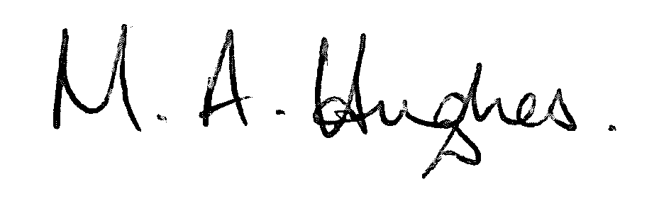

Ms M Hughes
Pennaeth / Headteacher

