19th October 2021

Dear Parent/Guardians

We have been advised that there have been confirmed cases of COVID-19 across years 7 – 12 in the school. We therefore ask that you be vigilant for symptoms of COVID-19 in your child.

The most common symptoms of COVID-19 are:

- fever (greater than 37.8°C);
- new persistent/continuous cough; and/or
- loss or change in sense of taste or smell.

Should your child develop any COVID-19 symptoms, please do not send your child to school but get a PCR test immediately. This can be arranged via the on-line portal https://gov.wales/get-tested-coronavirus-covid-19 or by phoning 119. If anyone in your household develops any of these symptoms, however mild, they should also seek a PCR test as soon as possible. If the outcome of your child’s PCR test is positive, they will be required to self-isolate for a period of 10 days.

As a school we are not always aware of personal circumstances and there may be vulnerable adults or children within your household or extended contact group. I hope that by giving you this information it may assist you in any decisions you may make regarding visiting elderly or vulnerable people and protecting those close to you.

Should your child remain clear of the symptoms outlined above, you do not need to take any further action, this letter is for information only. However, you may receive further correspondence from the Test Trace Protect (TTP) team who may provide you with further information and instructions. If you do not hear from them you can continue as normal.

Anyone who is fully vaccinated (with a period of 14 days having passed since the full vaccination course was completed) or is under the age of 18 does not need to self-isolate if they are identified as a close contact of a confirmed case, unless they are advised to do so by TTP.

To help keep others safe, there are still some things you/your child can do to reduce the risk of spreading the infection.

For the next 10 days we recommend you/your child:
- Be alert for new symptoms.
If you/your child start to feel unwell, no matter how mild the symptoms are, you/your child should stay away from school and get a PCR test.

- Keep washing hands regularly.
This is still an important way to limit the spread of many infections, including COVID-19.

We know how disruptive the last year has been for everyone. This year we want to minimise disruption for both students and staff whilst also helping to keep our communities safe from the effects of COVID-19. As a school, we will also be taking further mitigating action by asking staff and students to wear face coverings in the classroom for the next four days. We will then review the situation after the half term break.

Should you have any further questions/concerns, please email admin@penglais.org.uk. With continued thanks for your co-operation.

Yours sincerely,

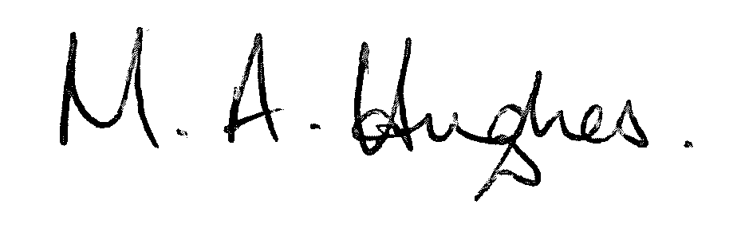

Ms M Hughes
Pennaeth / Headteacher

