2nd November 2021

Dear Parents/Guardians,

In light of Mark Drakeford's latest announcement regarding the changes to self-isolation, the new guidance is stated below.

If someone in your household has symptoms of coronavirus or has tested positive:

• If you are fully vaccinated or under the age of 18 (excluding children aged 0 – 4)
You must self-isolate and take a PCR test. If your test result is negative you can stop isolating and return to school. In these instances, secondary school pupils are still advised to take daily LFD tests for 7 days following their return to school. If any LFD result returns a positive result, the result should be uploaded onto the National portal and a PCR test should be undertaken. Where a result is positive, the individual will need to isolate for 10 days.

• If you are not fully vaccinated and aged 18 or over
You must self-isolate for 10 days. You should get a PCR test on day 2 and day 8 even if these are negative you must continue to isolate for the full 10 days.

• For a child under 5
A child under 5 years of age does not have to isolate or take a Covid test if they have been a contact of a positive case – household or other. However, they should not attend nursery /childcare setting if they are symptomatic or unwell.

Please remember:
If you have any coronavirus symptoms (a high temperature, a new continuous cough or a loss or change of taste or smell), you should self-isolate at home and get a test. You should not go to a GP surgery, pharmacy or hospital. Self-isolation applies to adults and children of all ages.
Self-isolation means that you do not leave the house. You should self-isolate straight away if you have symptoms and until you receive the results of a COVID-19 PCR test.
If you have tested positive for COVID-19, or have been told to self-isolate by the NHS Wales Test, Trace, Protect (TTP) service, you must stay at home. You are breaking the law and could be fined if you do not stay at home and self-isolate.

All this of course, to look after each other and keep our communities as safe as possible. Thank you for your co-operation. Should you have any queries, please contact admin@penglais.org.uk.

Yours sincerely,
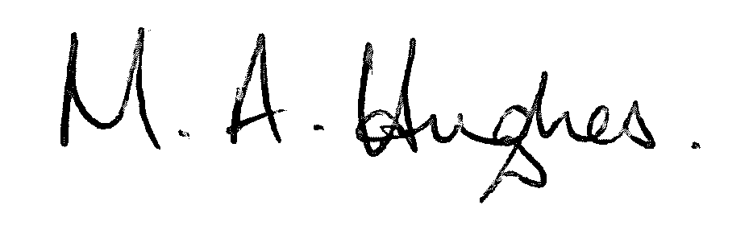
Ms M Hughes
Pennaeth / Headteacher

