21st December 2021

Dear Parents/Guardians,

We have reached the end of another challenging term that has ended in not quite the way we anticipated with the last two days of learning being online. However, as always, staff, students and parents have risen to the challenges and have responded well to the demands made of them. Students and staff have worked tirelessly over the last seven and a half weeks and certainly deserve a well-earned break now. Thank you to the students, staff and parents/guardians in enabling students to work purposefully, learn a great deal and ensure that they have been well-cared for during the half term.

Unfortunately, we are not certain as to how the pandemic will unfold over the next two weeks. Therefore, in order to give schools time to assess their staffing capacity and put in place the necessary measures to support learners returning, the Welsh Government has decided to give each school two planning days at the beginning of next term (5th and 6th January 2022). Schools will not provide any online/blended learning during these days. Students in Ceredigion schools will be welcomed back to school on Friday 7th January 2022. Payments/vouchers will continue for those families who are entitled to free school meals provision for their children.

Depending on the Covid context, we may see changes in the way schools operate when they return in January. We will continue to assess the situation in conjunction with the Local Authority, Welsh Government and Public Health Wales. We will share any relevant updates with you as appropriate.

This is a rapidly evolving situation and we urge you to take extra care to keep yourself and those around you as safe as possible.

I would like to thank you for your patience and continued co-operation. Best wishes to you and your family at Christmas.

Yours sincerely,

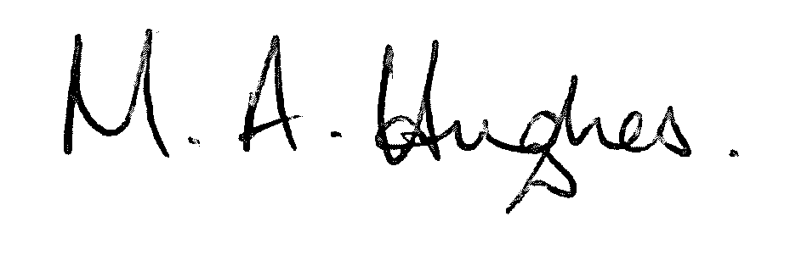

Ms M Hughes
Pennaeth / Headteacher

