25th November 2021

Dear Parents/Guardians,

Use of changing rooms

You will be aware that since returning to school in September 2020, we have not been using the changing rooms for PE lessons and students have been coming in to school in their PE kit. Since the start of this academic year in September, we have been reviewing the number of Covid cases in the school with the intention of re-opening the changing rooms as soon as possible. We are now in a place where we consider it safe to re-open the changing rooms.

Therefore, from Monday 29th November, students will be using the changing rooms for their PE lessons. Students will not be allowed to come into school in their PE kit for any reason and will be expected to bring their PE kit with them to change at the start and end of each lesson.

Students’ PE kit can get wet and muddy when taking part in the lessons, especially as we now enter the winter months. It is important, therefore, that students can change so that they can continue comfortably with the rest of their school day.

Students have been informed of this change in their PE lessons this week and through their form tutors. We would very much appreciate your support in ensuring that all students conform to this expectation.

I will also remind students and parents/guardians that non-school jumpers/hoodies are not allowed in the school. Students should wear their school jumper and a coat.

Thank you in advance for your co-operation.

Yours sincerely,

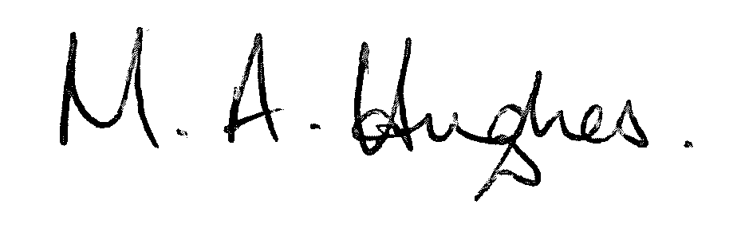

Ms M Hughes
Pennaeth / Headteacher

