1st December 2021

Dear Parents/Guardians,

You may be aware that the Welsh Government made an announcement on Monday evening regarding further precautions that schools should take in light of the uncertainties around the new Omicron variant of concern. The guidance states that:
‘Face coverings should be worn by staff and visitors in all indoor areas of all educational settings…including classrooms, where physical distance cannot be maintained.
Face coverings should be worn by secondary aged learners in all indoor areas, including classrooms, where physical distance cannot be maintained.’
Therefore, from Wednesday 1st December, all staff and students must wear a face covering in all indoor areas, where physical distance cannot be maintained, until further notice, unless they are exempt. This includes corridors, classrooms and canteen when not eating or drinking. Students and staff are not required to wear a face covering outside. Students must continue to wear a face covering on school transport, unless they are exempt from wearing a face covering.

There has also been speculation in the media that the school term may end early. This is not something that has been confirmed by the Welsh Government therefore we are currently still expecting to end the term on Tuesday 21st December.

Thank you for your support in ensuring that your child is able to follow these expectations. Should you have any concerns or questions, please email admin@penglais.org.uk.

Yours sincerely,

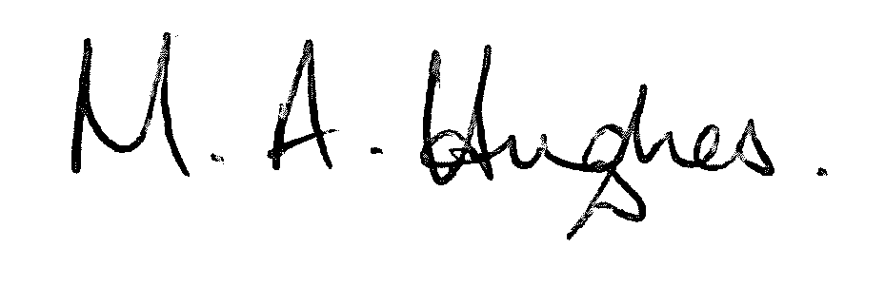

Ms M Hughes
Pennaeth / Headteacher

