6th January 2022

Dear Parents/Guardians,

Happy new year! I hope that you had a joyful Christmas and new year that wasn’t impacted too much by Covid. As we have seen already at the start of this term, Covid is likely to have an impact on the community and potentially the school over the next few weeks. This letter sets out some important changes so please read carefully.

You will be aware that Covid figures in Wales are very high at the moment and this is similar in Ceredigion. To reflect this, the Welsh Government have increased the risk level to very high and therefore we have reviewed our Risk Assessment to this level. You will also be aware that Ceredigion changed the date that the majority of students return to school on-site to Monday 10th January.

Therefore, on Friday 7th January, we look forward to welcoming Year 11 and 13 students back on-site. Students in Years 7, 8, 9 10 and 12 will have online lessons. This will follow the same format as the two days before Christmas with students expected to log on with their form tutor at 9am and then lessons will follow the KS4 and 5 timing with lessons starting at 9.10, 11.25 and 1.35. We will look forward to welcoming all students back on-site on Monday 10th January.

As a school, we had maintained many of the procedures to minimize risk, such as the one-way system, the 3-lesson structure and staggered lunch and breaks. In terms of the risk assessment there are changes as follows:
- Face coverings will be worn in all classrooms, corridors and canteen (when not eating or drinking).
- Contact groups are re-introduced as year groups in secondary schools. Therefore, all extra-curricular activities will now be year-based.
- There will be no inter-school activities for the time being.
- Year-based areas indoors will be maintained and students will be reminded of the out-door year-based areas.
- Assemblies will continue virtually.
- No visitors or parents on site
It is also essential that face coverings are worn on school transport. This is an area that students had become less compliant with towards the end of last term. Please remind your child that all students, unless they are medically exempt, must wear a face covering whilst travelling on the school buses.

As you will have seen in the media, the main risk for schools this month is maintaining staffing levels so that schools can remain open. We are determined to keep the school open for as many students as possible and will be reviewing staffing levels on a daily basis. Any decision made to move to online learning for a year group will be only on an emergency basis, will be discussed with Local Authority officers and will be as short-term as possible. We will prioritize students in Years 10 to 13 being on-site and will inform parents/guardians as quickly as possible if students need to be taught on-line. However, a decision may need to be made late in the evening and a message will be sent out to parents/guardians via Parentmail and via social media (Facebook and Twitter). I understand that this may be problematic and appreciate your co-operation in advance. Should Years 7 or 8 need to move to on-line learning for a short-period of time, the school will run a childcare hub for children of critical workers only, should they have no other options for childcare.

Changes to Lateral Flow Test (LFT) requirements
Preventing Covid from entering the school site is the most effective way of preventing the spread of Covid. Therefore, the Welsh Government are now advising school staff and students to use the Lateral Flow Test three times a week. We are requesting that this is done on Sunday, Tuesday and Thursday evenings between 5 and 7pm. Should there be a positive result, please log the result on the Welsh Government website and email the school at testing@penglais.org.uk.

There have been changes to the PCR requirements. If the LFT is positive and your child shows no symptoms, they no longer have to request a PCR test; they should self-isolate for 7 days. If your child tests positive on the LFT and does display symptoms, then they should request a PCR test.

Not all students have signed up to take LFTs. It is important that as many students as possible take LFTs on a regular basis to help keep everyone in the school safe. Should you now wish for your child to take LFTs regularly, please complete the attached form and return electronically to admin@penglais.org.uk, or ask your child to hand it in to Student Services.

Changes to self-isolation for positive cases
Should your child test positive for Covid, they have to self-isolate for 7 days. They should take an LFT on day 6 and day 7 and if they are both negative, they can return to school. If not, they should self-isolate for the 10 days.

Contacts
There is no longer a requirement for close contacts to take a PCR test. Should your child be contacted by TTP and told that they are a close contact, they must take a daily LFT for 7 days. Providing that the child remains symptomless and the LFTs return a negative result, the child can continue to come to school.

I appreciate that there is a lot of important information in this letter. Thank you in advance for your co-operation in making the next few weeks work as smoothly as possible for students and staff in the school. As ever, should you have any questions or comments, please email admin@penglais.org.uk.

Yours sincerely,
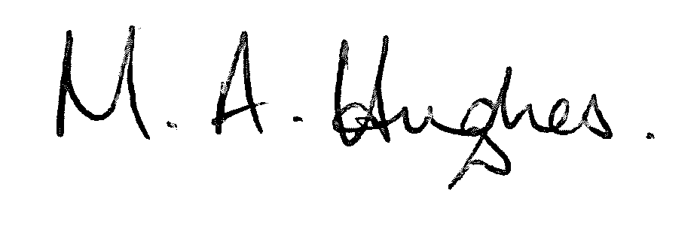
Ms M Hughes
Pennaeth/Headteacher

