10th January 2022

Dear Parents/Guardians,

You may be aware that in November, Qualifications Wales and WJEC shared information regarding contingency arrangements should the examination series not run this summer. It is clear that the aim certainly is for the exam series to run in May and June for Years 11, 12 and 13. However, they have asked schools to prepare assessments between now and the summer in case the exams are not able to run due to the disruption caused by Covid-19.

On Thursday 13th January at 6pm, we will be holding a webinar for parents/guardians and students in Years 11, 12 and 13 to explain the contingency arrangements for students at Penglais. It is important that as many parents/guardians and students as possible attend the webinar because we will give key information regarding the process and the timeline. The recording of the webinar and the powerpoint will then be available on the website for parents/guardians and students to access.

To access the webinar, please click on the link below.

https://teams.microsoft.com/l/meetup-join/19%3ameeting_NmY0YjJjZjUtNzZhZS00Zjc0LTkwNGYtZjUwYjBiMDM2M2M5%40thread.v2/0?context=%7b%22Tid%22%3a%224f3f0e52-b734-4164-9409-1b601d147993%22%2c%22Oid%22%3a%22c25aa25c-ddf5-4761-a64f-e5dece5b316b%22%2c%22IsBroadcastMeeting%22%3atrue%7d&btype=a&role=a

We look forward to seeing you on Thursday.

Yours sincerely,

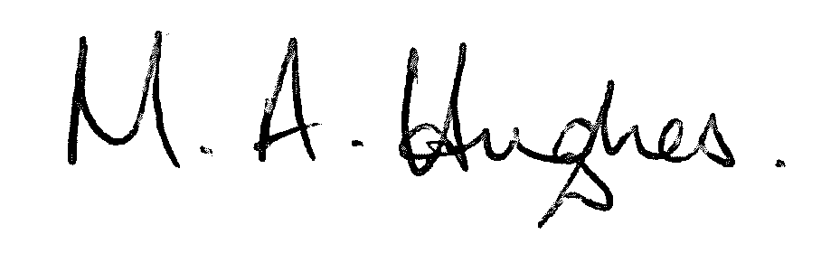

Ms M Hughes
Pennaeth / Headteacher

