healthy school b&w.tifeco school clear bkgrd side by side.tifactive marc cymru clear.tifai to photoshop test top lh.tifgriffin clear bkg.tif

**Exams Update – February 2022**

Dear Parent / Guardian

Students in Years 10-13 have been issued with their exam entries and timetable of their exams due in May and June. It is an important time for students to check their entries for accuracy and use the timetable to help with their revision. Please check these documents with your child as any problems identified reduces problems during the exam season.

On the statement of entry, please check that the student name and date of birth is correct, the name on exam certificates has to be the legal name at the time of the exam. Any changes can be made without charge at this time, but if certificates have to be printed again due to errors in the personal details these now cost around £50 per certificate.

The statement of entry also shows ALL the exam entries, and will show non-examination units. All Year 12 and 13 subjects and modular courses in Year 11 (such as English Literature, Welsh second language) must also have a cash in entry. A cash in entry is an entry to instruct the exam board to add up all the unit marks and issue a final grade. If there are any subject entries missing, or entries not needed, students need to see me during morning registration next week. I need these students to go to Reception and ask the staff there to ring me, and I will then meet with the students. Any changes can be made without charge at this time. I have shown the entry fees on the statement of entry for students to see how expensive these entries are, it is only for re-sits students may be charged for entries.

The written exam timetable will show the dates and times of all the written exams for your child in May and June. It also shows the candidate number, students need to know this four digit number and have used them in their mock exams. The timetable also helps students to check they are entered for the right subjects, but they will not show any non-examination entries (such as Welsh Baccalaureate entries, or controlled assessment units). Students may have exam clashes shown on this timetable, this is where they have more than one exam at the same time. Modern Foreign Languages exams will have listening and reading exam units during the same exam session, these are not clashes. I will see students with exam clashes during late March / early April after all entries are confirmed. Where the total time of these exams exceeds three hours, we can move one exam to either the morning or afternoon session from the other exam.

Last week we were also issued with ‘advance information’ in some units on some subjects and the details of this will be shared with students by their teachers. Further details on this can be found on the WJEC website ([www.wjec.co.uk](http://www.wjec.co.uk)) under student support and at [www.jcq.org.uk](http://www.jcq.org.uk), under Awarding Arrangements, and then Summer 2022 arrangements. Most of our subjects are with WJEC exam board, and the Wales regulations are different from the ones in England. In Wales, we have had adapted arrangements to reflect time lost due to covid, this means some subjects have had reduced content, some have had reduced non-exam requirements and some subjects have had more options introduced into exams. The advance information in a small number of units, for a small number of subjects, is to help students with revision as it gives more guidance on the topics with more extended questions. It is important that students understand it does not mean areas of the course do not need to be revised for, all parts of the content may be examined, the advance information is to help students focus some areas of revision.

The WJEC website also has a lot of resources in the student support section, not only on the exams process but also lots of information on support and wellbeing. WJEC have built this section up over recent years, and you will find a lot of useful advice and information in this section.

Yours faithfully

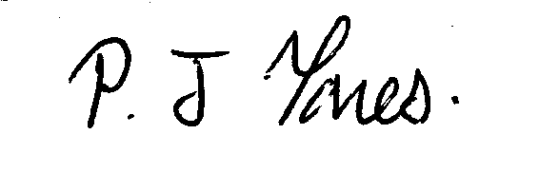

Exams Officer

*Ffôn/* Tel: 01970 624811

*Ffacs/*Fax: 01970 625830

*E-bost/*E-mail: admin@penglais.org.uk

*Gwefan/*Website: www.penglais.org.uk

Waunfawr

Aberystwyth

Ceredigion

SY23 3AW

*Pennaeth / Headteacher:- Ms Mair Hughes*

Yours sincerely

Mr R Edwards

Art Department