17th February 2022

Dear Parents/Guardians,

We have been advised by Ceredigion County Council that all schools will be closed tomorrow. See their statement below:

Ceredigion schools will be closed tomorrow (18.2.22) due to the very high winds forecast across the county.

Winds could reach up to 70-80 miles per hour, with stronger gusts possible. Information has been provided by the Local Resilience Forum, and organisations such as Welsh Government, Met Office and Natural Resources Wales that the conditions as a result of the storm are highly likely to cause significant damage to buildings and travelling in such conditions would be dangerous.

We do not wish to take any unnecessary risks and compromise the safety of children, young people and staff. Pupils will be able to continue with their learning on line, with schools setting appropriate tasks for the 18.2.22

Please be vigilant and keep safe.

We will be setting work online for students. Students should log on to Teams, internet and electricity connections permitting, at 9am for their tutor time and then at 9.15, 11.15 and 1.35 for the start of each lessons. There will be no live learning and teachers will set work for students to complete at home.

I hope that you will be able to stay safe and then enjoy your half term.

Yours sincerely,

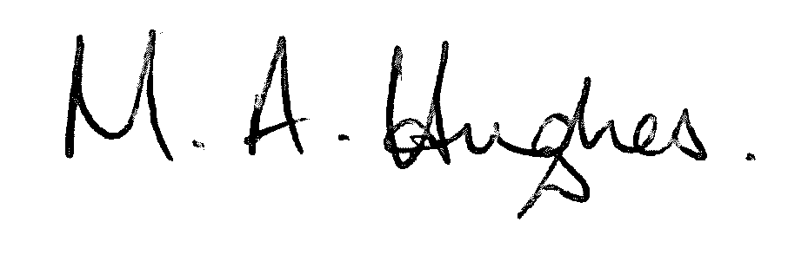

Ms M Hughes
Pennaeth / Headteacher

