27th May 2022

Dear Parents/Guardians,

It has been a busy half term, with Year 10, 11, 12 and 13 students starting their formal exams. We have been very impressed with the attitudes of the students and wish them well in their remaining exams. You will also be aware that we had a visit from Estyn during the last week. Thank you to everyone who completed the questionnaire and attended the parents’ evening. The report will be published on July 20th 2022.

As you are aware, when we returned following the first lockdown we made changes to the school day to reduce contact between students and staff. The two main changes were: moving to a 3-lesson day of 100 minutes, and having staggered lunch and break times.

Since the spring term, we have been reviewing both of these elements to decide whether they are structures that we wish to keep in the future. We have looked at progress in lessons, curriculum structure, discussed with students, listened to parents’ and guardians’ views as well as staff views.

We have decided to return to a 5-lesson day structure from September 2022. This allows for better flexibility and breadth in the curriculum as well as better sustained concentration from students leading to improved learning.

We have also decided to return to non-staggered lunch and break times. This will allow the school to re-introduce lunchtime clubs and activities across all year groups, which is such an important part of the school day for students. These clubs and activities enable students to develop various skills and have different, enjoyable experiences.

The return to non-staggered lunch and break times will take place after half term, starting on Monday 6th June. As you will have seen from a letter sent earlier in the week, the canteen manager has changed the structure in the canteen with different serveries offering various types of foods. Therefore, there will be no restriction on which areas of the canteen that different year groups use. Students will be able to choose the food they wish from the appropriate servery and then sit with their friends in any area of the canteen.

We will also be re-starting lunchtime clubs from the 13th June and a timetable of offered clubs and activities will be shared with students and families after half term.

As we are ending this half term, it is good to see the Urdd National Eisteddfod returning to a field rather than the virtual Eisteddfod that we have had over the last two years. We wish all the best to students who are taking part and hope that those of you visiting will enjoy Denbigh and its surrounding area.

I hope that you have an enjoyable half term and we look forward to students returning on Monday 6th June.

Yours sincerely,

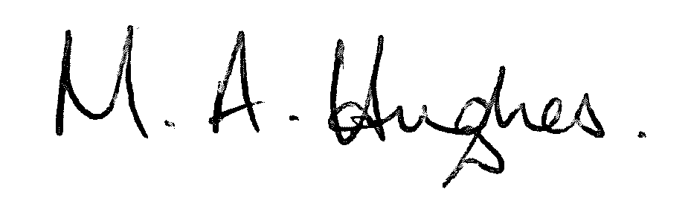

Ms M Hughes
Pennaeth / Headteacher

