July 2022

Dear Parents/Guardians and students,

Information about collecting exam results

- GCE Results’ day is Thursday 18th August (Year 12 and 13 students)

- GCSE Results’ Day is Thursday 25th August (Year 10 and 11 students and any Year 12 and 13 students re-sitting English / Maths GCSE)

The school will be open for students to collect their results from 08.30 – 12.00 on these days.

Students are strongly advised to come in and collect their results. On the results days, further information is available, such as grade boundaries, and staff will be available to meet with students to discuss their results. This support can be very important, particularly in discussing their options based on the results, grade boundaries and potential ordering of scripts and reviews of marking. This can be especially important when students are applying to university or college places.

On GCE Results’ Days it is also advised students collect their results early in the morning.

Exam results are not given out over the telephone or e-mailed. It was only when schools were not allowed to open due to Covid that results were generated and sent by e-mail. If students have made other arrangements for results’ days, they can e-mail Miss W Tyniec on W.Tyniec@penglais.org.uk giving permission for their parent or another student to collect their results. We will not be able to give the results to anyone else without the written instruction of the student.

If you require any further information please email Miss Tyniec.

Yours sincerely,
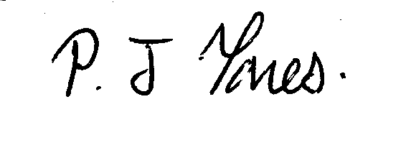

Mr P Jones
Exams Officer

