9th January 2023

Dear Parents/Guardians,

Happy New Year! I hope that you have had a peaceful and happy Christmas and new year and that you and your families are looking forward to 2023. We are anticipating a busy and productive year at Penglais, however aware that there will be challenges facing everyone through the next few months due to the cost of living increases and also the increase in illnesses that are present within society. Following advice from the health boards, we do ask that you are mindful of your child’s health and do not send your child into school if they have a high temperature. The Welsh Government also recommend that a face covering is worn if an individual has a cough or a sore throat. This is something that we will encourage within the school. We work closely with outside agencies to support families and may be able to offer support through the difficulties that may lie ahead. Please contact your child’s Head of Year should you feel that you and your family could benefit from further support.

This half term is a particularly busy one for students in Years 9 and 11 as they will be starting to consider their options for GCSE and post-16. Year 9s will have an Option Evening on Thursday 19th January which will be an opportunity for parents/guardians and students to visit the school to gain an understanding of the options process and have conversations with Subject Leaders about the option subjects at GCSE. This will be followed by an online parents’ evening on Thursday 9th February and the deadline for students making their choices is Thursday 16th February.

Year 11 students are invited to the 6th Form Open Evening in Penglais on Thursday 26th January which will be an opportunity for parents/guardians and students to understand more about the 6th Form and have discussions with Subject Leaders and 6th Form prefects about the subjects they may be considering taking at post-16. This will be followed by an online parents’ evening on Thursday 2nd February and the deadline for students making their initial option choices is Thursday 9th February.

You will be aware that the leadership structure of the school is changing slightly for the next two terms. Capacity has increased in the Senior Leadership Team and the table below outlines the responsibilities of members of the Senior Leadership Team.

Name | Role | Responsibilities
Ms Mair Hughes | Executive Head | Overall strategic planning and direction; Budget and financial management; Staffing; Leadership; Reporting to Governing Body
Ms Hayley Leighton | Head of School | Pupil progress and achievement; Inclusion; Day to day staffing; Overall curriculum offer
Mrs Rachael Allen | Assistant Head | New curriculum; Assessment and reporting; Faculty Lead for Humanities
Mr Phil Jones | Senior Leader | Learning environment; Exams and BTEC; Health and Safety; Day to day management of site
Mr Gareth Phillips | Assistant Head | Teaching and Learning; Professional Learning for staff; Performance Management; Welsh ethos and language
Mrs Mererid Thomas | Assistant Head | Safeguarding (Designated Safeguarding Officer); Strategic school behavior and attendance; Student progress and wellbeing in KS3; Emotional and mental health and wellbeing; Transition KS2-3
Mrs Karina Shaw | Assistant Head | Additional Learning Needs Co-ordinator (ALNCo); Learning Support Centre and Hearing Resource Centre; Looked After Children; Young Carers
Mrs Jess Davies | Associate Assistant Head | Area of Learning and Experience – Languages, Literacy and Communication; Faculty Leader for English
Mr Andy Fisher | Associate Assistant Head | Achievement and Standards; Head of Year 11

Faculty Leaders have responsibility for the teaching and learning and progress of students in their subject areas and Heads of Year have responsibility for the wellbeing and progress of students in their year group.

Should you have any concerns regarding your child, the first point of call should be your Head of Year. If you have any concerns or queries regarding other issues, please email admin@penglais.org.uk.

The Headteacher Surgery will continue on a Thursday evening from 5-6pm and will be run by Ms Leighton for this half term. This is an opportunity for parents/guardians to drop-in without an appointment if they have anything they would like to raise.

Thank you in advance for your continued support and co-operation.

Yours sincerely,

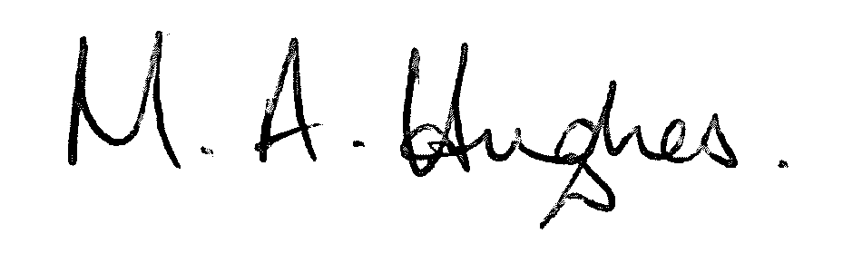

Ms M Hughes
Pennaeth Gweithredol / Executive Headteacher

