Penglais Curriculum - Aim
Ysgol Penglais School
Curriculum Summary 2023
The Curriculum for Wales (CfW) has provided an opportunity to develop a bespoke curriculum for our school community that builds clearly on our school vision and values, and provides all students with the opportunities to develop in the ways described in the four purposes. The Penglais curriculum has been developed from thorough research into curriculum, learning and pedagogy by teachers and leaders, reflection on what students want from their schooling, and consultation on what parents and the community value. It aims to establish a strong culture for learning, secure deep knowledge of a range of subjects, and provide opportunities for students to broaden their experiences and extend their capabilities.

Penglais Curriculum – Whole School Vision
Ysgol Penglais School is a happy, ambitious and high achieving school where everyone is respected and valued. We are a strong community where everyone cares for each other, knowing that only through collaboration and respect will we achieve and become our very best. The school is vibrant with students and staff co-operating, learning, thinking and working hard. We recognise that overcoming challenges is key to success and by developing bravery, confidence and resilience our students will become successful citizens of their communities, Wales and the world.

The new Penglais curriculum reflects the whole school vision and values.

Penglais Curriculum - Principles
These form the foundations of our school curriculum. They have been developed in consultation with all stakeholders and, alongside the CfW Statements of What Matters and Descriptions of Learning, help leaders and teachers to make decisions about the threshold concepts, knowledge, skills and experiences that happen along the curriculum journey at Penglais.

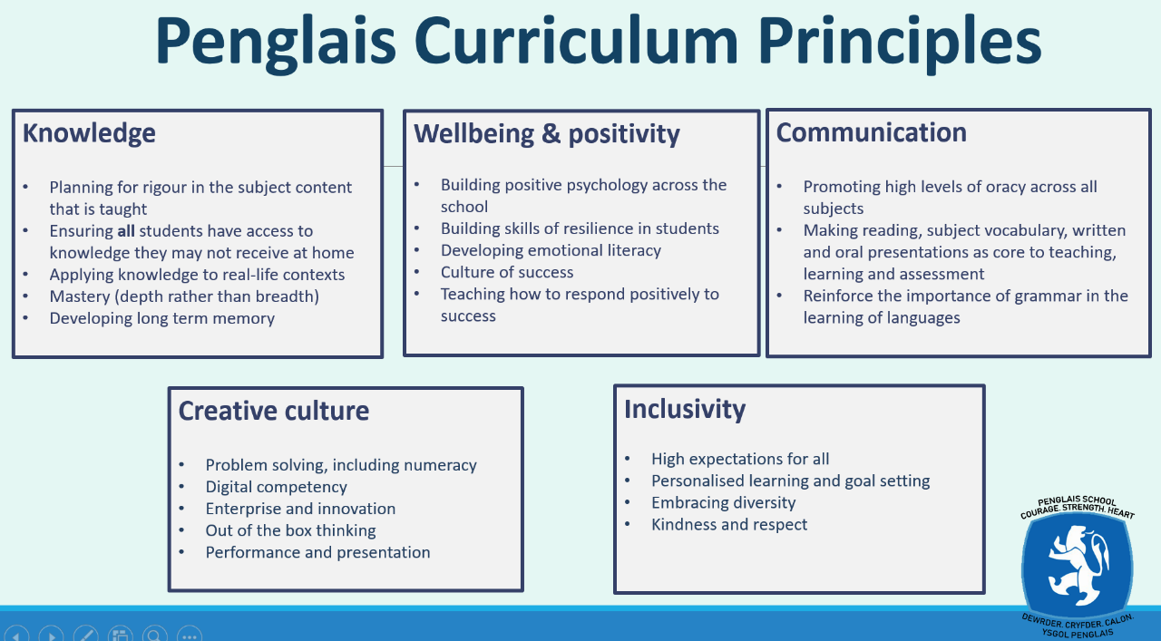
All subject Programmes of Learning identify how the concepts, knowledge, skills and experiences of that unit support the Penglais Principles.

Penglais Curriculum - Meeting the needs of all students
The Penglais curriculum is structured to support all students in making progress. This is achieved through differentiation; teachers identify, develop and apply the pedagogy required to support all learners in making progress. Students with ALN have an individualised development plan that teachers use when planning the learning. Students with ALN are supported and monitored; some students receive intervention to develop specific skills such as literacy and numeracy. The LUCID Exact and LUCID Recall tests provide information at the start of the year on the literacy skills, cognitive processing and working memory of all students; these are accessed by all teachers, who use it to plan suitable ways to support the progress of individual students. Students with English as a second language are supported through pre and post tutoring in the EAL department as well as specialist teacher support in lessons. More able students are supported with differentiated questioning, challenging success criteria and opportunities to extend their learning. The curriculum in specialised ALN units such as Canolfan Ni and Hearing Resource Centre is bespoke, in order to address the very specific physical and cognitive needs of the individual students in these units.

All subject Programmes of Learning in an AoLE identify how a unit supports the learning of all students.

Penglais Curriculum -The Four Purposess
The Penglais curriculum will ensure that all students have the opportunities to develop the knowledge, skills and experiences to become:

- ambitious, capable learners, ready to learn throughout their lives
- enterprising, creative contributors, ready to play a full part in life and work
- ethical, informed citizens of Wales and the world
- healthy, confident individuals, ready to lead fulfilling lives as valued members of society
All subject Programmes of Learning in an AoLE identify how and what a unit of work delivers to support the development of the Four Purposes.

Penglais Curriculum - Statements of What Matters
The Penglais curriculum provides opportunities and experiences to develop the concepts, knowledge and skills as described in the statements of What Matters and in line with the Statements of What Matters Code.
Curriculum for Wales: statements of what matters code GOV.WALES

All subject Programmes of Learning in an AoLE identify the links to the statements of what matters in a unit.

Penglais Curriculum – Areas of Learning & Experience
The Penglais curriculum will provide learning experiences through the 6 AoLEs:

• Languages, Literacy and Communication
• Expressive Arts
• Science and Technology
• Humanities
• Maths and Numeracy
• Health and Wellbeing

There are opportunities for individual subjects within AoLEs to collaborate on developing interdisciplinary links across subjects in order to improve the learning of concepts and skills, as well as providing opportunities for students to extend their capabilities. These opportunities are mapped across year groups and identified in subject Programmes of Learning.

Penglais Curriculum – Cross Curricular Skills: Literacy, Numeracy, Digital Competency
The Penglais curriculum develops the mandatory cross-curricular skills of literacy, numeracy and digital competence. These skills are also evident in the Penglais Curriculum Principles. Our curriculum enables students to make progress in the skills identified in the cross-curricular skills frameworks, and to extend and apply them across all Areas of Learning. Teachers with whole school responsibility for delivery of the framework will map where the skills are being delivered to ensure quality and coverage, support teachers, and track student progress in these skills.

All subject Programmes of Learning in an AoLE identify where and how a unit delivers the cross curricular skills.

Cross-curricular skills frameworks - Hwb (gov.wales)

Penglais Curriculum – Relationships and Sexuality Education RSE
Relationships and Sexuality Education (RSE) is a statutory requirement of the Curriculum for Wales. The Penglais curriculum RSE provision will adopt a whole school approach that encompasses the knowledge, skills, dispositions and values that will empower learners to:
- support their health and well-being
- develop healthy, safe and fulfilling relationships of all kinds, including those with family and friends, and in time, romantic and sexual relationships
- navigate and make sense of how relationships, sex, gender and sexuality shape their own and other people’s identities and lives
- understand and support their rights and those of others to enjoy equitable, safe, healthy and fulfilling relationships throughout their lives and advocate for these

Summary of legislation - Hwb (gov.wales)

Penglais Curriculum – Religion Values and Ethics RVE
Religion, Values and Ethics (RVE) is a statutory requirement of the Curriculum for Wales and is mandatory for all learners from ages 3 to 16. RVE is a locally determined subject; the agreed syllabus specifies what should be taught in RVE within the local authority and our curriculum reflects this guidance. The Penglais curriculum delivers learning about religious beliefs and non-religious beliefs through lessons in Humanities for year 7,8 and 9, and through tutor time and drop-down curriculum events in years 10 and 11.

Summary of legislation - Hwb (gov.wales)

Penglais Curriculum – Careers and Work-Related Experiences CWRE
The Penglais curriculum incorporates careers and work-related experiences for all of our students. The teacher with responsibility for CWRE across school maps the curriculum provision and works with Careers Wales to identify and deliver work-related experiences.

All subject Programmes of Learning in an AoLE identify where and how a unit delivers opportunities to learn about careers specific to the subject.

Penglais Curriculum – Diversity
The Penglais curriculum provides opportunities for students to:
- develop empathy and compassion for others
- celebrate diverse backgrounds, values and characteristics
- develop their own values and sense of identity
- develop understanding of people with different beliefs and perspectives
- challenge stereotypes

The Penglais school community is diverse; we endeavour to ensure that all students see themselves and their experiences represented in the topics, experiences and knowledge developed through the curriculum.

Penglais Curriculum – Human Rights
The Penglais curriculum promotes knowledge and understanding of Part 1 of the UNCRC, and of the UNCRPD, among those who provide teaching and learning.

Penglais Curriculum – English and Welsh (Cymraeg)
The Penglais curriculum delivers learning in both Cymraeg and English through lessons in the Language, Literacy and Communications AoLE. There is consideration of the language starting points of students when beginning their career at Penglais, so that teaching and learning can be planned appropriately. The ambition is that everyone learning in Penglais is supported to enjoy using Cymraeg, to make continuous progress in learning Cymraeg and to have the confidence and language skills so they can choose to use Cymraeg beyond the classroom, and in the local community.

Penglais Curriculum – Progression and Assessment
The Penglais curriculum is designed so that students can progress meaningfully in knowledge, understanding and skills along the continuum of learning from 3-16, in all AoLE. All subjects within an AoLE use the Principles of Progression, Statements of What Matters and Descriptions of Learning in the CfW to inform their planning for progression, and this is evidenced in subject Programmes of Learning for all units.

The Penglais assessment model addresses standards of mastery within a unit and levels of progress across a term, and aims to inform planning for future learning. Low stakes baseline assessment information establishes the starting point for students in terms of knowledge, understanding and skills, and helps teachers to plan the learning for a unit. Ongoing formative assessment by teachers in lessons supports the learning and provides evidence of progress over time. Summative assessments give evidence of standards of mastery achieved by students at the end of the unit. The assessment information is used by teachers and leaders to address issues with progress and standards; potential barriers to learning are identified and actioned by subject teachers, and leaders.

Whole school baseline assessment information, levels of mastery, levels of progress, attitude to learning and attendance are reported to students and parents/guardians at the end of each term.

Penglais Curriculum – Evaluation, Review and Refinement
The Penglais curriculum and assessment model will be evaluated, reviewed and refined as part of the whole school, faculty, and department self-evaluation and improvement planning process. This is informed by ongoing evidence collection and evaluation that takes place through the year including parent voice, student voice, looking at learner evidence, assessment outcomes and data walls. Any changes to the curriculum summary will be agreed by the Governing Body (as necessary) and published.
Adoption of the Penglais Curriculum (Curriculum for Wales)

Headteacher: Ms Mair. Hughes

Chair of Governors: Dr John Moorby

Date:20th June 2023 Review date: 20th June 2024

R. Allen June 2023

