27th October 2023

Dear Parents/Guardians,

The half term has been a busy one and we have been very impressed by how well most students have settled back into school and into their learning. Most students work well, listen well and maintain our value of being respectful and kind at all times. They have been busy not just in their learning but also in the range of extra-curricular activities that are offered at lunchtimes. Please do read the newsletter if you haven’t yet done so, in order to get a flavour of some of the events that have taken place over the half term.

Next half term, we are focusing on improving a couple of issues within the school. One of these is to ensure that all students are punctual to school and to lessons. After half term, we will be recording how many minutes late students are to lessons and students who are late will be making up the time the following day in lunchtime detention. Parents/guardians of children who are often late to lessons will be receiving a letter at the end of the week with the number of minutes that students have been late to lessons. Please reiterate to your child the importance of being punctual both to school and to lessons.

We will also be ensuring that students use the toilets sensibly. Students are encouraged to ensure that they have used the toilets at break and lunchtime in order to minimize the need to go during lesson time. If students want to go to the toilet during lesson time, they will need a note in their planner from the teacher. Of course, if they have a medical reason, this will not be a problem.

As it gets towards the winter, can we please ask you to ensure that your child is wearing the correct school uniform with a coat and does not wear a non-school jumper in the school.

Communication between school and parents/guardians is crucial and most communication is done professionally and sensibly. Can we please ask all parents/guardians to be respectful in their communication with staff, either through email or phone calls, so that we can maintain the positive relationships and communications.

I hope that you have a good half term and look forward to welcoming your child back on Monday 6th November.

Yours sincerely,
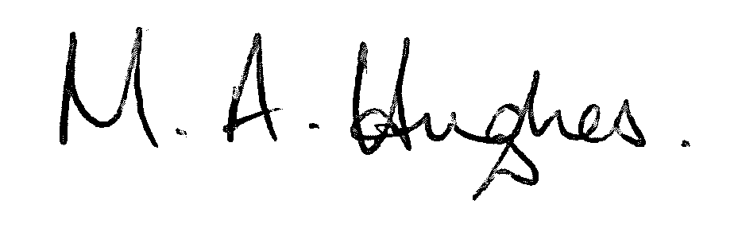
Ms M Hughes
Pennaeth / Headteacher

